# Docker 图形化工具 Portainer部署

必须先运行起来之后，再汉化。如果直接汉化会报错

#### 1 docker-compose.yml

version: '2'  
services:  
 portainer:  
 image: portainer/portainer:latest  
 container_name: portainer  
 privileged: true  
 restart:  
 always  
 volumes:  
 - /var/run/docker.sock:/var/run/docker.sock  
 - ${PWD}/data:/data  
 #- ${PWD}/public:/public  
 ports:  
 - "9000:9000"

#### 2 访问

<http://192.168.91.70:9000/#/init/admin>

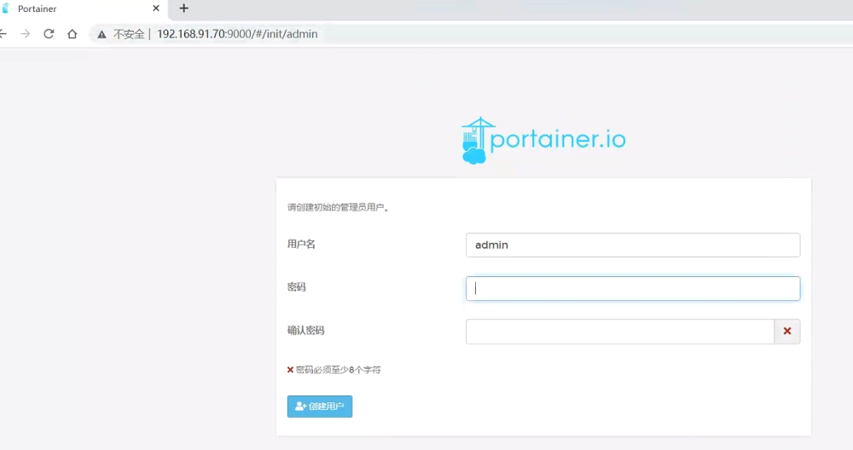

#### 3 汉化

<https://imnks.com/3406.html>

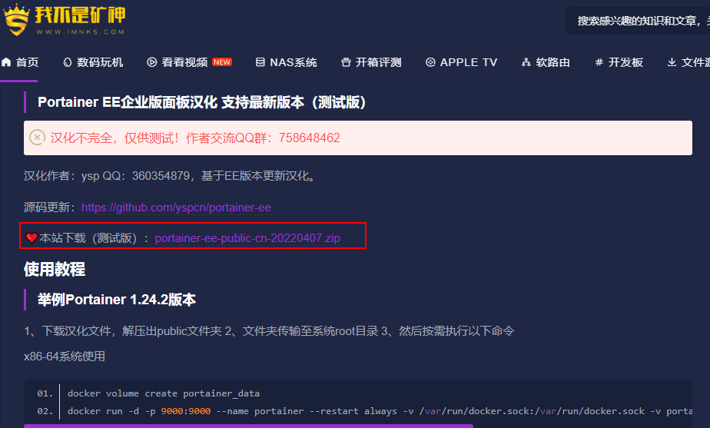

[📎portainer-ee-public-cn-20220407.zip](https://www.yuque.com/attachments/yuque/0/2022/zip/29027294/1670291097871-06ca22f0-5155-4784-8cac-cd886cb70ece.zip)

version: '2'  
services:  
 portainer:  
 image: portainer/portainer:latest  
 container_name: portainer  
 privileged: true  
 restart:  
 always  
 volumes:  
 - /var/run/docker.sock:/var/run/docker.sock  
 - ${PWD}/data:/data  
 - ${PWD}/public:/public #取消注释  
 ports:  
 - "9000:9000"

#### 4 参考文档

<http://t.zoukankan.com/leozhanggg-p-12040338.html>

<http://help.websoft9.com/docker-guide/portainer/readme.html>

<https://www.jb51.net/article/236237.htm> （开启远程管理）